Word-level analysis of the impact casued by COVID-19 on Mental Health

Srishti Vashishtha
Computer Science Engineering Dept.
The NorthCap University
Gurugram, Haryana, India
0000-0002-6281-5745
Yukta Yadav
Computer Science Engineering Dept.
The NorthCap University
Gurugram, Haryana, India
Yukti Agrarwal
Computer Science Engineering Dept.
The NorthCap University
Gurgram, Haryana, India

Abstract— COVID-19 has impacted the lives of all people around the world. The trauma of being locked up, economic loss, social distancing, closure of workplaces, educational institutions, etc. has imparted negative thinking in the mindset of humans. In this paper, we have discussed how the COVID-19 pandemic has affected the mental health of individuals. We have analyzed the most searched words related to mental health for seven countries- Canada, US, UK, Iran, Japan, South Korea and Italy. A comparative analysis of searched words in pre and post COVID-19 era for Canada indicates that the incremented search is due to fact that people are suffering from mental health issues like anxiety, stress, depression, etc.
Keywords— COVID-19, mental health, anxiety, stress, depression

Introduction
When epidemics arise, public health emergencies have impinged the health, safety, and social well-being of people and the society. The individuals suffer from insecurity, emotional isolation, stigma while the society agonizes due to economic loss, closure of offices and schools, inadequate resources for medical response, and deficient distribution of necessities. These effects during epidemics brings about a variety of emotional reactions in the form of stress, distress or psychiatric conditions. According to a WHO survey, the COVID-19 pandemic in 2020 has agitated or halted critical mental health services in 93% of countries worldwide, this has led to the increasing demand for mental health. It has been observed by WHO, prior to this pandemic the world-wide countries allocated less than 2 percent of their national health budgets on mental health. Now, during COVID-19 pandemic the growing demand for mental health services needs to be addressed. Home isolation, loss of salary and fear are provoking mental health conditions, many individuals are confronting incremented levels of alcohol and drug use, insomnia, and anxiety. Studies have indicated that people with pre-existing mental or psychological may stand a higher risk of stringent outcomes [1]. The major reason for the rise in mental health issues is the unpredictability and uncertainty of the COVID-19 pandemic; the correlated lockdowns, physical distancing, and other restriction strategies. Moreover, the consequent economic breakdown has raised the risk of mental health problems and aggravated health inequalities.
In this paper we have analyzed the impact of COVID-19 pandemic on mental health of people residing in different countries world-wide. Section II contains the related work about mental health issues caused due to COVID-19. The experimental setup details are mentioned in section III, followed by the results and analysis in section IV and section V concludes the paper.

Related Work
During this pandemic, words like “you’re alone or isolated”, “lockdown” and “social distancing” created a negative impact in the minds. These words were propagated through social media, TV, news channels, radio, etc. hence reinforcing that “you are isolated”; that led to adding to the perception of isolating oneself socially. In this section we have discussed recent papers that portray the repercussions caused by COVID-19 pandemic on the health of humans. Numerous studies have shown the negative impact caused by COVID-19 on public health and psychopathological symptoms developed due to stress and anxiety [2]. Mukaetova-Ladinska et al., introduces about neurocognitive functions which are cognitive functions closely linked to the function of particular areas, neural pathways, or cortical networks in the brain, ultimately served by the substrate of the brain's neurological matrix [3]. In several recent studies neurocognitive disorder symptoms due to the COVID-19 pandemic provide a unique opportunity to address changes occurring in central nervous system (CNS) at both clinical and molecular level. Recent studies provide a detailed information of where abouts of corona in different countries like India [4, 5], USA [7, 9], Australia [8] and UK [10] respectively. Studies have also revealed how lockdown caused bereavement, isolation, loss of income and fear which are in-turn triggering mental health conditions or worsening existing ones. Many people are facing consuming higher levels of alcohol and drug use; suffering from insomnia, anxiety and depression. Authors in [7,10] is stating a significant negative impact on mental health of college students and requirement of proactive efforts to support the mental health and well-being of students are needed. Holmes et al. focuses on multidisciplinary mental health science research by exploring the psychological, social, and neuroscientific effects of COVID-19 [6]. The potential effects on individual and population mental health, and its probable effect on the brain function of several affected by the disease has been discussed. One more important aspect has been show-cased which deals with culture and self, independent and interdependent and freedom and determination of self [11]. The agenda of “stay at home stay safe” proved to be wrong in some scenarios; this is true evidently as in lockdown period some individuals are getting violated in different ways which is causing depression that in turn force you to take extreme steps [12]. Since beginning there have been many cases of neurological and neuropsychiatric instances in patients with COVID‐19. The complexities associated with the neuropsychiatric instance of COVID‐19 have led to estimates of the potential incidences of related disorders and patients admitted to the psychiatric ward with worsening psychiatric symptoms [13].

Experimental Setup

The proposed approach is based on google search terms. Words play an important role in determining the opinions, feelings, sentiments and the mental outlook of an individual. Studies [14 -16] have proved that the word-level analysis of text written by individuals help in ascertaining the correct thought process. In this paper, the focus is around words, searched by people, that reflect mental health concern. Particularly, the authors have examined which words were searched by the public before and after epidemic of COVID-19 and what impact it had on people around the world. The search terms cover "mental health", "insomnia", "anxiety", "ocd", "obsessive compulsive disorder", "depression", "counselling", "psychiatrist", "panic attack" which had been the major exploration of the pandemic in the areas of Canada, US, UK, Iran, Japan, South Korea and Italy. This dataset contains information of Canada for the past 4 years, from 2016 to 2019 [17].
Search terms are shown by a number between and 100, where 100 implies the most prevalent point of the week whereas 1 implies the minimum. We have applied country wise analysis where different growth search terms is compared over time. A keyword analysis has also been implemented which compares each country’s trend rise along with comparison between Canada pre and post COVID-19.

Results And Discussions

In this section, we have analyzed the country wise data for the keywords related to mental health during the COVID-19 pandemic. In the analysis various search terms are compared over time. A keyword analysis has also been implemented which compares each country’s trend rise along with comparison between Canada pre and post COVID-19.

Analysis of Cases in United States:

The analysis for United States is deployed by combining all datasets for the region of US over the period of 50 weeks. Fig.1 depicts how individuals had looked through terms, the most searched term being anxiety for that year. “mental health” and “psychiatrist” were looked sooner or later in that year. “Obsessive compulsive disorder” had lowest trend in comparison.

Analysis of Cases in United Kingdom:

UK comes on top with cases starting in early April. Fig. 2 implementation gives data by consolidating all datasets for the area of UK over the time of 50 weeks. This figure portrays how people had peeked through the terms; the most looked through term was “anxiety” for that particular year. “Depression” and “ocd” were not that far behind while “psychiatrist” had minimal pattern in correlation.

Analysis of Cases in Italy:

Fig. 3 shows combination of all datasets for Italy for a duration of over a year. It also demonstrates how each search item reached its peak. The word “depression” reached its peak in the starting of 2020 whereas “obsessive-compulsive disorder”, “panic attack”, “mental health” and “counselling” were at their highest in end of 2019. “Anxiety”, “ocd”, “insomnia” and “psychiatrist” peaked after second month of 2020.

Analysis of Cases in Iran:

The examination of words for the country Iran is deliberated by means of joining all datasets for the location of Iran. Fig. 4 portrays how humans had studied via the search terms, the most appeared through time period being depression for that year. “anxiety” and “psychiatrist” had appeared ultimately in the following year. In contrast, the curve for “mental health” was lowest.

Analysis of Cases in Japan:

The data about Japan is constructed by combining all datasets for the region of the Japan throughout the period of 50 weeks. Fig. 5 depicts how individuals had examined the terms. “insomnia” made it to one of the top searched terms with a higher inclination in Japan. Insomnia is a sleep disorder in which you have trouble falling and/or staying asleep. “anxiety” was not so a long way behind while “obsessive compulsive disorder” had a comparably less contribution.

Analysis of Cases in South Korea:

While mapping out the dataset for South Korea, as shown in Fig. 6, it can be noticed how each search term arrived to its pinnacle. The word “panic attack” arrived at the top in the beginning of COVID-19 whilst “depression”, “anxiety”, “obsessive compulsive disorder” and “ocd” joined in as the cases of COVID-19 increased tragically. As the cases of insomnia increased with the start of 2020, “psychiatrist” term was also searched more often.

Post and Pre Canada in COVID-19:

Another interesting investigation is implemented for comparing the word search related to mental health in pre COVID-19 era and post COVID-19 era in Canada. The distinction in trends for pre-COVID-19 times and post COVID-19 times in Canada is depicted in Fig.7. The examination of the graph indicates that there's a rise within the search terms in nearly each section whereas there's a decrease in “counselling” and “psychiatrist”. One of the main reasons for this would be lockdown within the country; due to this epidemic there was a scare among people to go out and possibly catch the virus. The incremented search is due to fact that people are suffering from mental health issues like anxiety, stress, depression, etc. Hence, we should focus on solutions to decrease these health issues so that people can be happy again and adapt to live with this virus.

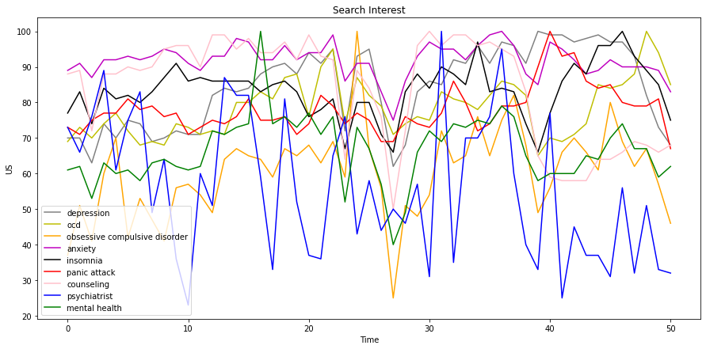
Fig. 1. Distribution of most searched words related to mental health during COVID-19 in United States.

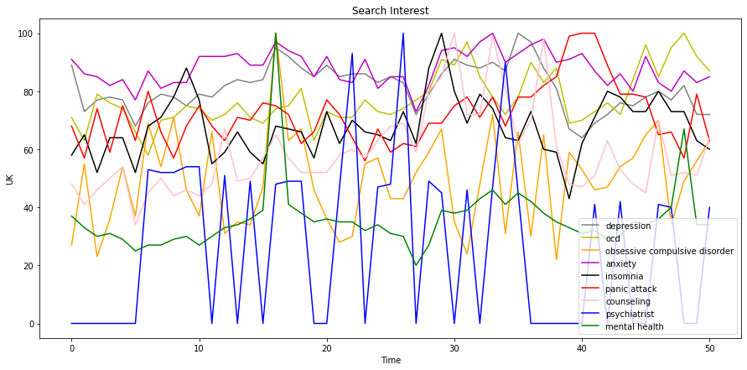
Fig. 2. Distribution of most searched words related to mental health during COVID-19 in United Kingdom.

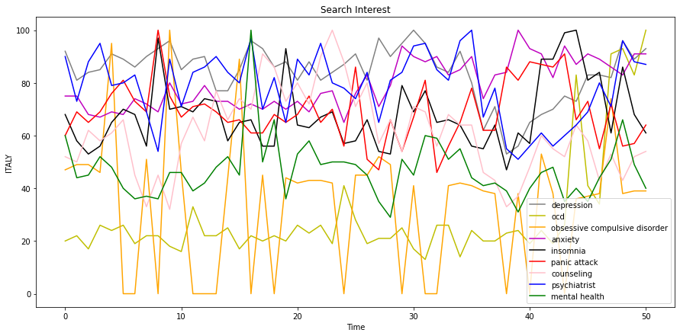
Fig. 3. Distribution of most searched words related to mental health during COVID-19 in Italy.
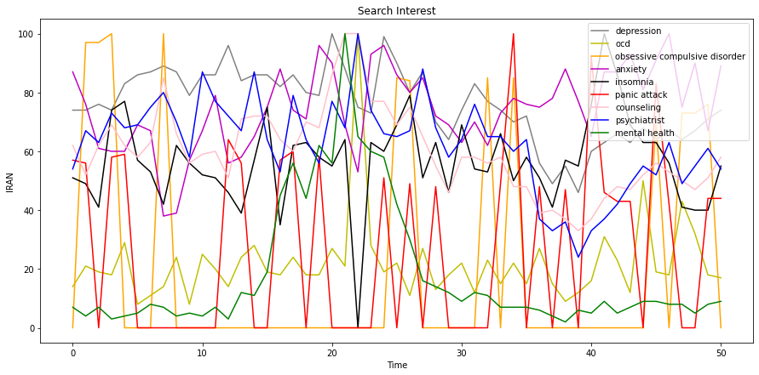
Fig. 4. Distribution of most searched words related to mental health during COVID-19 in Iran.

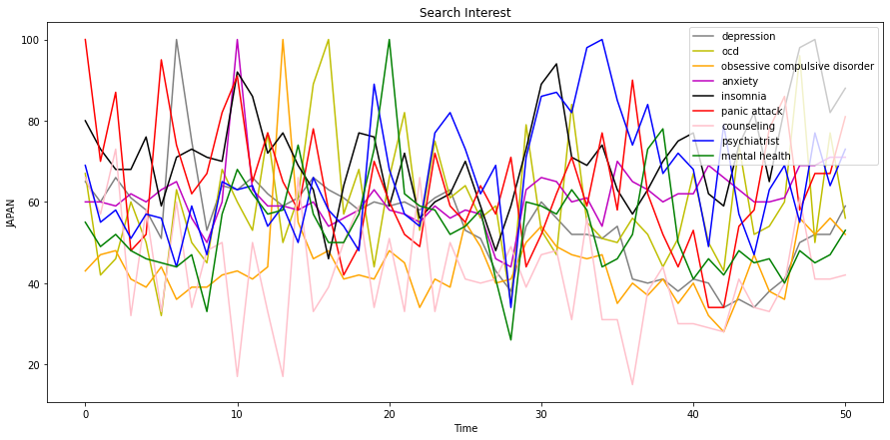
Fig. 5. Distribution of most searched words related to mental health during COVID-19 in Japan.
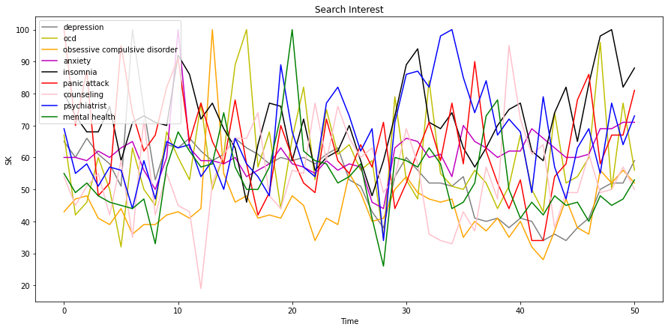
Fig. 6. Distribution of most searched words related to mental health during COVID-19 in South Korea.

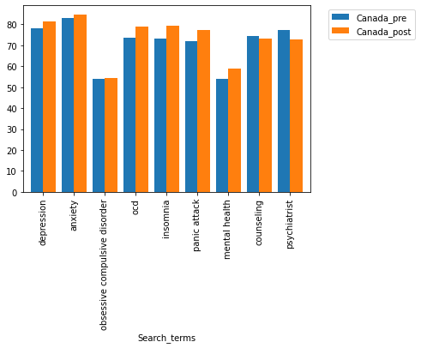
Fig. 7. Comparison of most searched words for pre and post COVID-19 era in Canada.

Conclusion

In this paper, we have discussed how the COVID-19 pandemic has affected the health of individuals. The adverse effect of pandemic can be observed by detecting an increased search for the words related to mental health. We examined the top mental health search terms and investigated their trend in various counties during this world-wide pandemic. These trends exhibited the mental crisis that dawned upon people across the globe over the course of 50 weeks.
Fig. 8 conveys how anxiety and depression took the top spots followed by insomnia which is closely associated to the

other two illnesses. The spikes in the graph portrays how different news or events caused a disrupt in the health of the general public.
The country wise analysis for each search term and the comparison between pre-COVID era and the post-COVID era has been presented. It can be clearly noticed that the people are suffering from various mental health issues like anxiety, stress, depression, insomnia, etc. This research demonstrates how people can not only be affected by fear of virus but also the cabin fear caused by it.
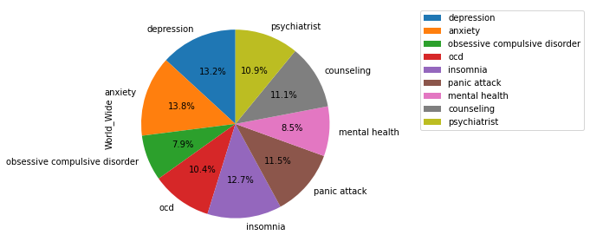
Fig.8 Distribution of most searched words related to mental health during COVID-19 in the world.

References

- RP. Rajkumar. "COVID-19 and mental health: A review of the existing literature." Asian journal of psychiatry 52 (2020): 102066.
- S.K. Schäfer, M. R. Sopp, C.G. Schanz, M. Staginnus, A.S. Göritz, and T. Michael. "Impact of COVID-19 on public mental health and the buffering effect of a sense of coherence." Psychotherapy and psychosomatics 89, no. 6 (2020): 386-392.
- EB. Mukaetova-Ladinska, G. Kronenberg, and R. Raha-Chowdhury. "COVID-19 and neurocognitive disorders." Current opinion in psychiatry 34, no. 2 (2021): 149.
- A. Roy, A. K. Singh, S. Mishra, A. Chinnadurai, A. Mitra, and O. Bakshi. "Mental health implications of COVID-19 pandemic and its response in India." The International journal of social psychiatry (2020).
- S. Das. "Mental Health and Psychosocial Aspects of COVID-19 in India: The Challenges and Responses." Journal of Health Management 22, no. 2 (2020): 197-205.
- EA. Holmes, R. C. O'Connor, V. H. Perry, I. Tracey, S. Wessely, Louise Arseneault, Clive Ballard et al. "Multidisciplinary research priorities for the COVID-19 pandemic: a call for action for mental health science." The Lancet Psychiatry (2020).
- C. Son, S. Hegde, A. Smith, X.Wang, and F. Sasangohar. "Effects of COVID-19 on college students’ mental health in the United States: Interview survey study." Journal of medical internet research 22, no. 9 (2020): e21279.
- A. Dawel, Y. Shou, M. Smithson, N. Cherbuin, M. Banfield, A.L. Calear, L.M. Farrer. "The effect of COVID-19 on mental health and wellbeing in a representative sample of Australian adults." Frontiers in psychiatry 11 (2020): 1026.
- A. Kecojevic, C.H. Basch, M. Sullivan, and N.K. Davi. "The impact of the COVID-19 epidemic on mental health of undergraduate students in New Jersey, cross-sectional study." PloS one 15, no. 9 (2020): e0239696.
- M. Pierce, H.Hope, T. Ford, S. Hatch, M. Hotopf, A. John, E. Kontopantelis. "Mental health before and during the COVID-19 pandemic: a longitudinal probability sample survey of the UK population." The Lancet Psychiatry 7, no. 10 (2020): 883-892.
- A. Scalabrini, J. Xu, and G. Northoff. "What COVID‐19 tells us about the self–the deep inter‐subjective and cultural layers of our brain." Psychiatry and clinical neurosciences (2020).
- A. Pattojoshi, A. Sidana, S. Garg, S. Narayan Mishra, L.K. Singh, N.Goyal, and S. K. Tikka. "Staying home is NOT ‘staying safe’: A rapid 8‐day online survey on spousal violence against women during the COVID‐19 lockdown in India." Psychiatry and clinical neurosciences (2020).
- A. Zandifar and R Badrfam. "Exacerbation of psychosis accompanied by seizure and catatonia in a patient with COVID‐19: A case report." Psychiatry and Clinical Neurosciences (2020).
- S. Vashishtha and S. Susan. "Sentiment Cognition from Words Shortlisted by Fuzzy Entropy." IEEE Transactions on Cognitive and Developmental Systems 12, no. 3 (2019): 541-550.
- S. Vashishtha and S. Susan. "Fuzzy Interpretation of Word Polarity Scores for Unsupervised Sentiment Analysis." In 2020 11th International Conference on Computing, Communication and Networking Technologies (ICCCNT), pp. 1-6. IEEE, 2020.
- S. Vashishtha and S. Susan. "Fuzzy logic based dynamic plotting of mood swings from tweets." In International Conference on Innovations in Bio-Inspired Computing and Applications, pp. 129-139. Springer, Cham, 2018.
- Accessed on 15th Mar2021, https://www.kaggle.com/luckybro/mental-health-search-term

